**HAND GESTURE CONTROLLED**

**WHEELCHAIR**

***The project report submitted to***

**Veermata Jijabai Technological Institute, Mumbai**

***For the award of***

**DIPLOMA IN ELECTRONICS ENGINEERING**



Atharva Rajendra Jadhav (194130055)

Soham Sameer Kale (194130030)

Amey Vinay Sonawadekar (194130045)

Farhan Asif Shaikh (194130026)

**Department of Electronics Engineering**

**Veermata Jijabai Technological Institute, Mumbai**

**Maharashtra, India**

**Academic Year 2021-22**

**HAND GESTURE CONTROLLED**

**WHEELCHAIR**

***The project report submitted to***

**Veermata Jijabai Technological Institute, Mumbai**

***For the award of***

**DIPLOMA IN ELECTRONICS ENGINEERING**

**By**

Atharva Rajendra Jadhav (194130055)

Soham Sameer Kale (194130030)

Amey Vinay Sonawadekar (194130045)

Farhan Asif Shaikh (194130026)

***Under the guidance of***

Prof. Jyoti A Gondane



**Department of Electronics Engineering**

**Veermata Jijabai Technological Institute, Mumbai**

**Maharashtra, India**

**Academic Year 2021-22**

**Veermata Jijabai Technological Institute, Mumbai**

**Department of Electronics Engineering**

**Approval of the Guide and the External Examiner**

Certified on dd/mm/yyyy, that the project titled “Hand Gesture controlled Wheelchair” has been submitted by the following Project group:

1. Atharva Rajendra Jadhav (194130055)
2. Soham Sameer Kale (194130030)
3. Amey Vinay Sonawadekar (194130045)
4. Farhan Asif Shaikh (194130026)

to the Veermata Jijabai Technological Institute, Mumbai for the award of DIPLOMA IN ELECTRONICS ENGINEERING and that the students have successfully examine in the viva voce examination held today.

Signature:

Guide: Prof. Jyoti A Gondane

Affiliation: Department of Electronics Engineering, Veermata Jijabai Technlogical Institute, Mumbai, Maharashtra, India

Signature:

External Examiner:

Affiliation:

**ACKNOWLEDGEMENT**

The success and final outcome of this project required a lot of guidance and assistance from many people and we are extremely privileged to have got this all along the completion of the project. All we have done is only due to such supervision and assistance and we would not forget to thank them.

The project was possible only with the inspiration and timely guidance of our Project Guide Prof. Jyoti A Gondane who was always available to help and answer us at any time and provided us in all the necessary information for developing a good system.

We are thankful to and fortunate enough to get constant encouragement, support and guidance from all the teaching staff of Electronics and Electrical Department who helped us in successful completion of the project.

Lastly, we would like to thank our classmates for the encouragement and help without whom this project would not have been possible.

Thank You Again!

1. Atharva Rajendra Jadhav (194130055)
2. Soham Sameer Kale (194130030)
3. Amey Vinay Sonawadekar (194130045)
4. Farhan Asif Shaikh (194130026)

Department of Electronics Engineering, Veermata Jijabai Technological Institute, Mumbai

**DECLARATION**

We certify that,

* The work contained in this report is original and has been done by me under the guidance of my guide.
* The work has not been submitted to any other Institute for the award of my diploma, or certificate.
* We have followed the guidelines of the Institute in preparing the thesis.
* Whenever we have used materials (data, theoretical analysis, figures, text, etc.) from other sources, we have given due credit to them by citing them in the text of the thesis and giving their details in the references necessary.

|  |  |  |
| --- | --- | --- |
| Sr No | Name of Student | Signature |
| 1 | Atharva Rajendra Jadhav |  |
| 2 | Soham Sameer Kale |  |
| 3 | Amey Vinay Sonawadekar |  |
| 4 | Farhan Asif Shaikh |  |

**LIST OF FIGURES**

|  |  |  |
| --- | --- | --- |
| **FIGURE NO.** | **FIGURE NAME/CAPTION** | **PAGE NO.** |
|  |  |  |
|  |  |  |
|  |  |  |
|  |  |  |
|  |  |  |

**LIST OF TABLES**

|  |  |  |
| --- | --- | --- |
| **TABLE NO.** | **TABLE NAME/CAPTION** | **PAGE NO.** |
|  |  |  |
|  |  |  |
|  |  |  |
|  |  |  |
|  |  |  |

**LIST OF ABBREVIATIONS**

In alphanumeric order

|  |  |
| --- | --- |
|  |  |
|  |  |
|  |  |
|  |  |
|  |  |
|  |  |
|  |  |
|  |  |

**CONTENTS**

|  |  |
| --- | --- |
|  | **Page No.** |
| Cover Page | 1 |
| Title Page | 2 |
| Approval of the Guide and External Examiner | 3 |
| Acknowledgement | 4 |
| Declaration by the students | 5 |
| List of figures | 6 |
| List of tables | 7 |
| List of abbreviations | 8 |
| Contents | 9 |

|  |  |  |
| --- | --- | --- |
| **CHAPTER NO.** | **NAME** | **PAGE NO.** |
| **Chapter 1** | **INTRODUCTION** |  |
|  | 1.1 objective and aim |  |
|  | 1.2 motivation |  |
| **Chapter 2** | **LITERATURE SURVEY** |  |
|  | 2.1 disability |  |
|  | 2.2. symptoms |  |
|  | 2.3 causes |  |
|  | 2.4 impact |  |
| **Chapter 3** | **MARKET SURVEY** |  |
|  | 3.1 |  |
|  | 3.2 |  |
|  | 3.3 |  |
|  | 3.4 |  |
|  | 3.5 Our wheelchair |  |
| **Chapter 4** | **DESIGN OF EXPERIMENTAL SETUP** |  |
|  | 4.1 |  |
|  | 4.2 |  |
| **Chapter 5** | **DEVELOPMENT OF EXPERIMENTAL SETUP** |  |
|  | 5.1 |  |
|  | 5.2 |  |
| **Chapter 6** | **COMPONENTS SPECIFICATION AND DESCRIPTION** |  |
|  | 6.1 |  |
|  | 6.2 |  |
|  | 6.3 |  |
|  | 6.4 |  |
|  | 6.5 |  |
| **Chapter 7** | **EXPERIMENTAL OBSERVATIONS** |  |
|  | 7.1 |  |
| **Chapter 8** | **RESULT AND DISPERSION** |  |
|  | 8.1 |  |
| **Chapter 9** | **SUMMARY AND CONCLUSIONS** |  |
|  | 9.1 |  |
|  | 9.2 |  |
|  | 9.3 |  |
| **Chapter 10** | **SCOPE FOR FUTURE WORK** |  |

**CHAPTER 1: INTRODUCTION**

* 1. **Objective and aim**

This project is an advanced approach of changing the physical gesture of hand into the electrical signal and then to process that signal into a digital signal of appropriate magnitude and to be transmitted through the transmitter. This project provides an instrumental solution to the people who have difficulty in moving or their body parts have paralyzed, or they have lost their limb in an accident. This wheelchair is going to bring a paradigm shift between man and machines. Where  this machine  will be  working on the user  commands,  we  can  also  say  its  human  machine interface. With the growth of technology there has always been an effort to use the technology for the betterment of mankind. Time and again the technocrats of the world had proved their metal in bringing comfort to the people who are in need with the help of technology.  Bringing the technology and economy parallel to each other is the paramount aim of this paper. Also to build a Hand Gesture Wheelchair which has sound technology but low in cost is the primary concern.  Today in this modern era around the world's 10 percent, around 650 million people are suffering from physical disability. In order to make their life a bit easier we decided to make a hand gesture controlled wheel chair which will be working on the gesture of their hand.   The wheel chair is wireless and has a range of (range to be put soon).  It means a person can control his wheelchair from (range to be put soon). The  disabled  people always find difficulties in moving from one room to another and  even  to  do  that  the  handicapped  person  was dependent on someone else who will push the wheelchair manually and take the handicapped person from one place to  another.  Now with the Hand Gesture Controlled Wheelchair the handicapped person is independent and he need not to ask for help from any other person to move his wheelchair.  Just  with  the  movement  of  his  hand  the handicapped  person  is  able  to  move  from  one  place  to another  without  needing anyone’s  assistance  which  also makes him self-dependent.

Wheelchair model photo

* 1. **Motivation**

The percentage of disabled people has increased in both rural and urban part of India. The disability could be by birth or due to some medical or accidental reason. The motivation behind this project is to make a hand gesture controlled wheelchair chair using an accelerometer as a sensor to help the physically disabled people in moving from one place to another just by   giving  direction from  the hand.  Today in India many people are suffering from disability, there are people whose lower half of the body is paralyzed. This Wheelchair will add on to the comfort and make the life of people a bit easier. Around 5436604 people are affected from movement disability.

For disabled people, a wheelchair is a vital piece of equipment. The majority of wheelchairs are operated manually, which is extremely difficult for disabled persons. To alleviate this difficulty, we designed a prototype of an automated wheelchair that can be operated with simple hand gestures in this project. This wheelchair can also be controlled remotely, which is an added benefit. The project's main components were a gyro sensor and a Bluetooth module. Gyro sensors are utilized to detect hand gestures while maintaining the I2C protocol. The Bluetooth module is utilized to keep the wheelchair and the controller in communication. The master is the transmitting gesture controller. The receiving unit, which is a wheelchair, on the other hand, serves as a slave. The fundamental goal of this project was to develop new medical equipment that was cutting-edge in technology, simple to use, and cost-effective.



**CHAPTER 2: LITERATURE SURVEY**

**2.1 Disability**

A disability is any condition of the body or mind (impairment) that makes it more difficult for the person with the condition to do certain activities (activity limitation) and interact with the world around them (participation restrictions).

Conditions such as **cerebral vascular accident, spinal cord injury, traumatic brain injury (TBI), cancer, amputation, musculoskeletal injury, or neuromuscular diseases** may result in impaired lower limb function and lead to considerable temporary or permanent disability.

**Types of people who are:**

a. Paralytic person.

b. Those who crawl.

c. Those who walk with the help of aid.

d. Those have acute and permanent problems of joints/muscles.

e. Those who have stiffness or tightness in movement or have loose, involuntary movements or tremors of the body or have fragile bones.

f. Those who have difficulty in motor cell and neurons coordination.

g. Those who have lost sense of sensation in lower part of the body due to paralysis or other problems.

h. Those who have twisted body parts and suffer from any kind of deformity in the body.



**2.2 Symptoms**

A physical disability is a limitation on a person's **Physical functioning, mobility, dexterity or stamina**. Other physical disabilities include impairments which limit other facets of daily living, such as respiratory disorders, blindness, epilepsy and sleep disorders. **Strictly speaking Locomotor Disability means** **problem in moving from one place to another** i.e. disability in legs. But, in general, it is taken as a disability related with bones, joints and Page 3 muscles. It causes problems in person's movements (like walking, picking or holding things in hand, etc.).

It is very important in the field of health related research to study the causes of mortality and disability. The pattern of causes provide a clear and in depth idea about the situation of the disease and injury prevalence in the population under study. There are numerous studies available worldwide (developed as well as developing countries) for causes of death, but very few such studies are available on the causes of disability in developing countries like India. Most often International agencies, governmental and non-governmental sources, mentioned the causes of disability are heredity, birth defects, lack of care during pregnancy and child birth, insalubrious housing, natural disasters, illiteracy and the resulting lack of information available on health services, poor sanitation and hygiene, congenital diseases, malnutrition, traffic accidents, work-related accidents and illness, sports accidents, the so-called diseases of ‘civilization' (cardiovascular disease, mental and nervous disorders, the use of certain chemicals, change of diet and life style etc.), marriage between close relatives, accidents at home, respiratory diseases, metabolic diseases (diabetes, kidney failure etc.), drugs, alcohol, smoking, high blood pressure, old age, chagus disease, poliomyelitis, measles etc.

**What are the most common causes of disability?**

* Illnesses like cancer, heart attack or diabetes cause the majority of long-term disabilities. Back pain, injuries, and arthritis are also significant causes.
* Most are not work-related, and therefore not covered by workers’ compensation.
* Lifestyle choices and personal behaviour that lead to obesity are becoming major contributing factors.
* Musculoskeletal disorders are the #1 cause of disabilities. Examples include; arthritis, back pain, spine/joint disorders, fibromytis, etc.

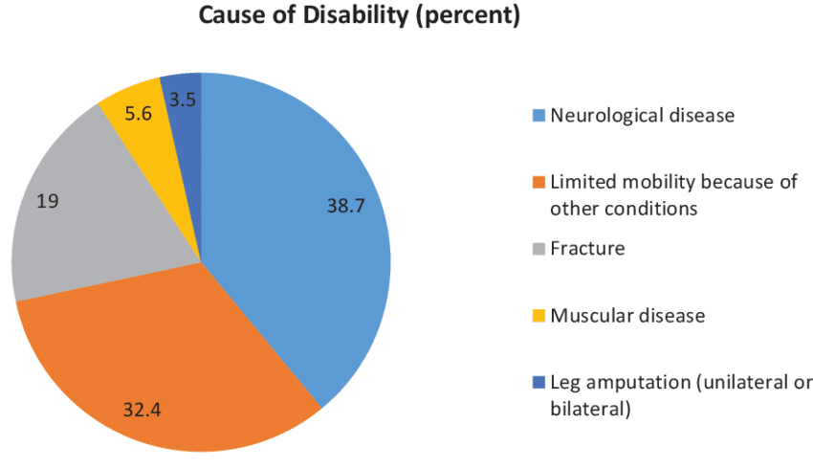

**2.3**

**2.4**

**CHAPTER 3: MARKET SURVEY**

**3.1 Frido GO Self Propelled Wheelchair**

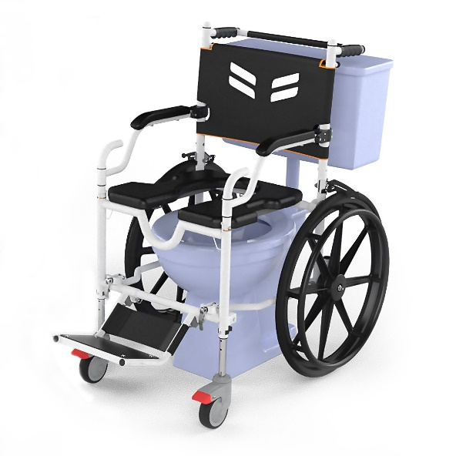

Frido GO SP, a rolling shower commode chair with a total width of 25 Inches for the narrow version and 27 inches for the wide version. Frido Go is designed and manufactured to the highest standards of assisted living mobility devices, specifically to cater to the daily common and traveling needs of individuals with spinal cord injury and physical movement related to mobility limitations. To cater to the daily or occasional travel needs of our users, The Frido GO SP has a quick and Easy Folding Mechanism and fits in a bag/suitcase which not only saves space while traveling but also can be carried with you at places. With the ease of our user & his/her family in mind, this rolling shower commode chair equips a swing-away armrest for easy wheelchair transfers and is also made up of stainless steel 304 for maximum protection against rust. With a Keyhole shaped cushion and the proven ability to roll over the commode directly, the Frido GO SP is designed to access toilets in a safe and dignified manner. The Frido GO SP also comes with a 2 level of height adjustments. Frido Go easily rolls over commode heights of 17 inches and 19 inches, which not only eases the transfers from bed to the chair but also allows the chair to roll over different commode heights.

**Estimated market price Rs. 41,999.00** per unit

**3.2 Kosmo Care Rider Wheelchair**

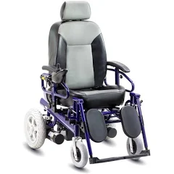

A reclining automatic wheelchair, it has an Aluminium frame and added features for comfort.

**Features:**

- Variable speed from 1 to 6 Km/hr. and extra power to take a 12-degree slope in its stride.

- Larger capacity Battery which helps It to travel up to 20 Km on a full charge.

- It has a reclining high back rest and comes with detachable and height adjustable armrests. The leg rests are detachable with calf support.

- Wider seats of 18" width, which are comfortably cushioned and added head rest.

- Extra strong frame can carry a load up to 125 Kg.

**Estimated market price RS. 1,01,400.00 per unit**

**3.3 Kosmo Care Recliner Junior**

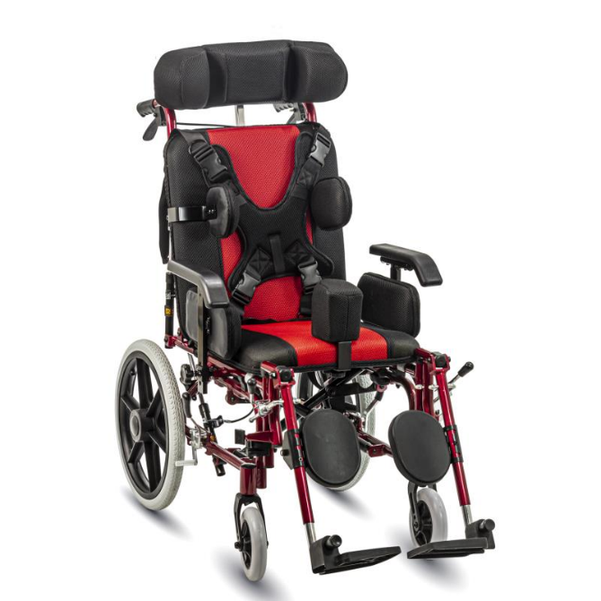

A fine quality wheelchair, it comes with reclining high back and extra cushioned upholstery. It is specially designed for children with cerebral palsy.

**Features:**

* Folding wheelchair with detachable; height adjustable desk jet armrest for easy transfer to/from bed & detachable footrest.
* Lightweight aluminium alloy anodized frame.
* Elevating footrests to rest legs at various levels and calf supports. Height adjustable and detachable head rest.
* A hydraulic reclining high back for a comfortable posture. Detachable back and seat cushion and an anti-tripping mechanism to prevent it from tipping when tilted.
* Hard cushioned seat and back. The smaller seat width of 15" (38 cm) with cloth look like water proof upholstery and a safety belt for added safety.
* Load carrying Capacity: 100 Kg/220 lb.
* Net Weight (approx.): 18.5 Kg/ 41 lb.

**Estimated market price Rs. 28,405.00** per unit

# **3.4 Freedom Power Wheelchair A08L**

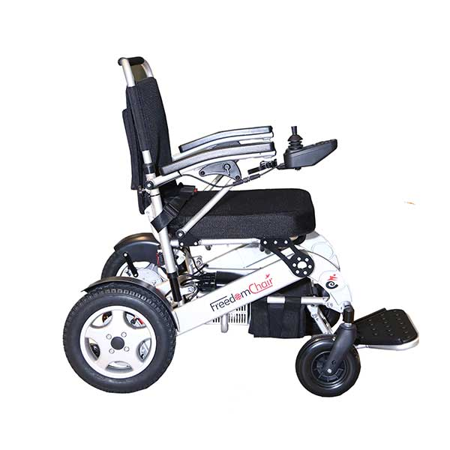

The Freedom Electric power wheelchair is a heavy-duty lightweight foldable automatic wheelchair with a lithium battery. This electric wheelchair has brushless motors, Controlled by the joystick and joystick can be fixed on either armrest.  Freedom Automatic wheelchair makes light work cobbled streets and rougher terrains. Height of the backrest is adjustable for the optimal comfort of the power wheelchair user. The electromagnetic brakes are automatically applied when the joystick is in the neutral position, preventing accidental rolling. The Joystick can be detached and keep safely when travelling.

**FEATURES:**

* This Electric Wheelchair Has Flip back armrests
* Detachable Joystick for extra safety of Electric wheelchair user
* Height Adjustable backrest for the optimal comfort of the wheelchair user
* Removable and tension adjustable backrest
* Detachable spacious storage bag
* Interchangeable joystick ( left or right side)
* Brushless motors
* Extra space for 2 spare batteries
* Four suspensions for a smooth ride on rough terrain
* Seat Belt
* Speed controller
* Battery indicator
* A horn button

**Estimated market price** **RS. 1,20,952.00** per unit

**3.5 Our wheelchair**

**CHAPTER 6: COMPONENTS SPECIFICATION AND DESCRIPTION**

# **6.1 Arduino Nano**

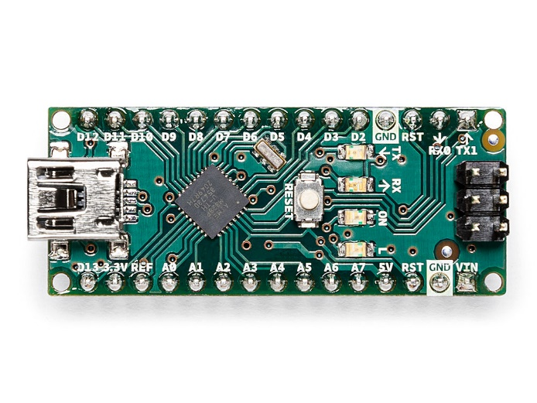

The Arduino Nano is a small, complete, and breadboard-friendly board based on the ATmega328 (Arduino Nano 3.x). It has more or less the same functionality of the Arduino Duemilanove, but in a different package. It lacks only a DC power jack, and works with a Mini-B USB cable instead of a standard one.

**Power :**The Arduino Nano can be powered via the Mini-B USB connection, 6-20V unregulated external power supply (pin 30), or 5V regulated external power supply (pin 27). The power source is automatically selected to the highest voltage source.

**Memory :** The ATmega328 has 32 KB, (also with 2 KB used for the bootloader. The ATmega328 has 2 KB of SRAM and 1 KB of EEPROM.

The Nano has 8 analog inputs, each of which provide 10 bits of resolution (i.e. 1024 different values). By default they measure from ground to 5 volts, though is it possible to change the upper end of their range using the analogReference() function. Analog pins 6 and 7 cannot be used as digital pins. Additionally, some pins have specialized functionality:

* I2C: A4 (SDA) and A5 (SCL). Support I2C (TWI) communication using the Wire library (documentation on the Wiring website).

**Programming :** The Arduino Nano can be programmed with the Arduino software . Select "Arduino Duemilanove or Nano w/ ATmega328" from the Tools > Board menu (according to the microcontroller on your board). The ATmega328 on the Arduino Nano comes preburned with a bootloader that allows you to upload new code to it without the use of an external hardware programmer. It communicates using the original STK500 protocol. You can also bypass the bootloader and program the microcontroller through the ICSP (In-Circuit Serial Programming) header using Arduino ISP or similar.

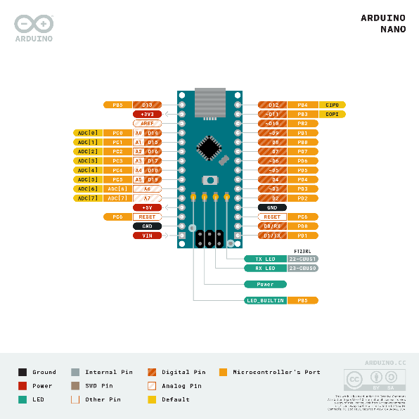

### Input and Output : Each of the 14 digital pins on the Nano can be used as an input or output, using pinMode(), digitalWrite(), and digitalRead() functions. They operate at 5 volts. Each pin can provide or receive a maximum of 40 mA and has an internal pull-up resistor (disconnected by default) of 20-50 kOhms. In addition, some pins have specialized functions:

* Serial: 0 (RX) and 1 (TX). Used to receive (RX) and transmit (TX) TTL serial data. These pins are connected to the corresponding pins of the FTDI USB-to-TTL Serial chip.
* External Interrupts: 2 and 3. These pins can be configured to trigger an interrupt on a low value, a rising or falling edge, or a change in value. See the attachInterrupt() function for details.
* PWM: 3, 5, 6, 9, 10, and 11. Provide 8-bit PWM output with the analogWrite() function.
* SPI: 10 (SS), 11 (MOSI), 12 (MISO), 13 (SCK). These pins support SPI communication, which, although provided by the underlying hardware, is not currently included in the Arduino language.
* LED: 13. There is a built-in LED connected to digital pin 13. When the pin is HIGH value, the LED is on, when the pin is LOW, it's off.

There are a couple of other pins on the board:

* AREF. Reference voltage for the analog inputs. Used with analogReference().
* Reset. Bring this line LOW to reset the microcontroller. Typically used to add a reset button to shields which block the one on the board.

### Communication : The Arduino Nano has a number of facilities for communicating with a computer, another Arduino, or other microcontrollers. The ATmega328 provide UART TTL (5V) serial communication, which is available on digital pins 0 (RX) and 1 (TX). An FTDI FT232RL on the board channels this serial communication over USB and the FTDI drivers (included with the Arduino software) provide a virtual com port to software on the computer. The Arduino software includes a serial monitor which allows simple textual data to be sent to and from the Arduino board. The RX and TX LEDs on the board will flash when data is being transmitted via the FTDI chip and USB connection to the computer (but not for serial communication on pins 0 and 1). A SoftwareSerial library allows for serial communication on any of the Nano's digital pins. The ATmega328 also support I2C (TWI) and SPI communication. The Arduino software includes a Wire library to simplify use of the I2C bus. To use the SPI communication, please see ATmega328 datasheet.

### Automatic (Software) Reset : Rather then requiring a physical press of the reset button before an upload, the Arduino Nano is designed in a way that allows it to be reset by software running on a connected computer. One of the hardware flow control lines (DTR) of the FT232RL is connected to the reset line of the ATmega328 via a 100 nanofarad capacitor. When this line is asserted (taken low), the reset line drops long enough to reset the chip. The Arduino software uses this capability to allow you to upload code by simply pressing the upload button in the Arduino environment. This means that the bootloader can have a shorter timeout, as the lowering of DTR can be well-coordinated with the start of the upload. This setup has other implications. When the Nano is connected to either a computer running Mac OS X or Linux, it resets each time a connection is made to it from software (via USB). For the following half-second or so, the bootloader is running on the Nano. While it is programmed to ignore malformed data (i.e. anything besides an upload of new code), it will intercept the first few bytes of data sent to the board after a connection is opened. If a sketch running on the board receives one-time configuration or other data when it first starts, make sure that the software with which it communicates waits a second after opening the connection and before sending this data.

# **6.2 MPU6050 Sensor Module**

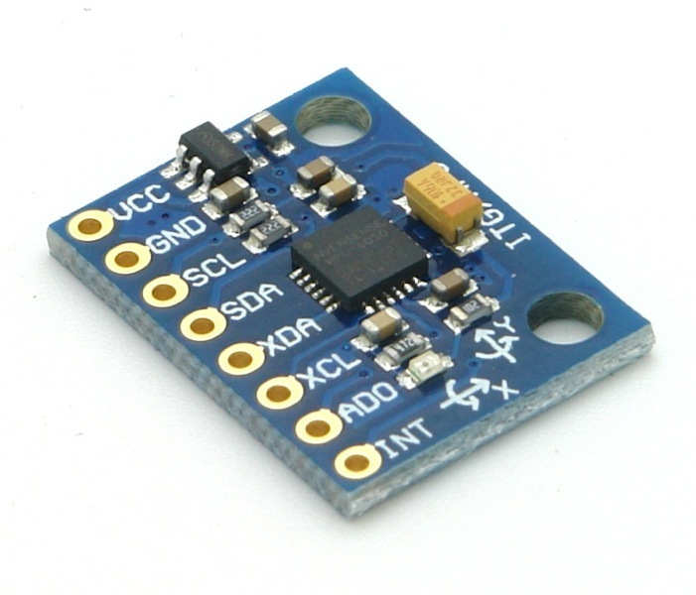

MPU6050 sensor module is complete 6-axis Motion Tracking Device. It combines 3-axis Gyroscope, 3-axis Accelerometer and Digital Motion Processor all in small package. Also, it has additional feature of on-chip Temperature sensor. It has I2C bus interface to communicate with the microcontrollers.It has Auxiliary I2C bus to communicate with other sensor devices like 3-axis Magnetometer, Pressure sensor etc.If 3-axis Magnetometer is connected to auxiliary I2C bus, then MPU6050 can provide complete 9-axis Motion Fusion output.

Let’s see MPU6050 inside sensors.

* **3-Axis Gyroscope**

The MPU6050 consist of 3-axis Gyroscope with Micro Electro Mechanical System(MEMS) technology. It is used to detect rotational velocity along the X, Y, Z axes as shown in below figure. When the gyros are rotated about any of the sense axes, the Coriolis Effect causes a vibration that is detected by a MEM inside MPU6050.

- The resulting signal is amplified, demodulated, and filtered to produce a voltage that is proportional to the angular rate.

-  This voltage is digitized using 16-bit ADC to sample each axis.

-  The full-scale range of output are +/- 250, +/- 500, +/- 1000, +/- 2000.

-  It measures the angular velocity along each axis in degree per second unit.

* **3-Axis Accelerometer**

The MPU6050 consist 3-axis Accelerometer with Micro Electro Mechanical (MEMs) technology. It used to detect angle of tilt or inclination along the X, Y and Z axes as shown in below figure.  Acceleration along the axes deflects the movable mass.

-  This displacement of moving plate (mass) unbalances the differential capacitor which results in sensor output. Output amplitude is proportional to acceleration.

-  16-bit ADC is used to get digitized output.

-  The full-scale range of acceleration are +/- 2g, +/- 4g, +/- 8g, +/- 16g.

-  It measured in g (gravity force) unit.

-  When device placed on flat surface it will measure 0g on X and Y axis and +1g on Z axis.

* **DMP (Digital Motion Processor)**

The embedded Digital Motion Processor (DMP) is used to compute motion processing algorithms. It takes data from gyroscope, accelerometer and additional 3rd party sensor such as magnetometer and processes the data. It provides motion data like roll, pitch, yaw angles, landscape and portrait sense etc. It minimizes the processes of host in computing motion data. The resulting data can be read from DMP registers.

* **On-chip Temperature Sensor**

On-chip temperature sensor output is digitized using ADC. The reading from temperature sensor can be read from sensor data register.

# **MPU-6050 Module**

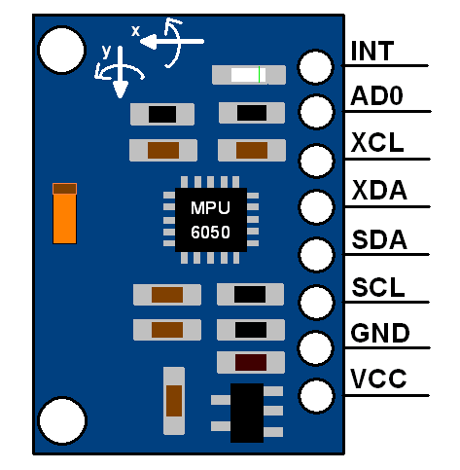

**The MPU-6050 module has 8 pins,**

**INT:**Interrupt digital output pin.

**AD0:**I2C Slave Address LSB pin. This is 0th bit in 7-bit slave address of device. If connected to VCC then it is read as logic one and slave address changes.

**XCL:**Auxiliary Serial Clock pin. This pin is used to connect other I2C interface enabled sensors SCL pin to MPU-6050.

**XDA:**Auxiliary Serial Data pin. This pin is used to connect other I2C interface enabled sensors SDA pin to MPU-6050.

**SCL:**Serial Clock pin. Connect this pin to microcontrollers SCL pin.

**SDA:**Serial Data pin. Connect this pin to microcontrollers SDA pin.

**GND:** Ground pin. Connect this pin to ground connection.

**VCC:**Power supply pin. Connect this pin to +5V DC supply.

# **6.3 Bluetooth Module HC-05**

# HC-05 Bluetooth Module

* It is used for many applications like wireless headset, game controllers, wireless mouse, wireless keyboard and many more consumer applications.
* It has range up to <100m which depends upon transmitter and receiver, atmosphere, geographic & urban conditions.
* It is IEEE 802.15.1 standardized protocol, through which one can build wireless Personal Area Network ([PAN](https://en.wikipedia.org/wiki/Personal_area_network)). It uses frequency-hopping spread spectrum ([FHSS](https://en.wikipedia.org/wiki/Frequency-hopping_spread_spectrum)) radio technology to send data over air.
* It uses serial communication to communicate with devices. It communicates with microcontroller using serial port (USART).

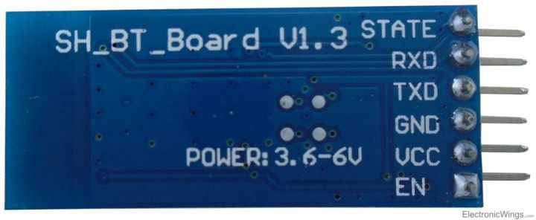

1.  **Key/EN:** It is used to bring Bluetooth module in AT commands mode. If Key/EN pin is set to high, then this module will work in command mode. Otherwise by default it is in data mode. The default baud rate of HC-05 in command mode is 38400bps and 9600 in data mode.

2.  **VCC:**Connect 5 V or 3.3 V to this Pin.

3.  **GND:**Ground Pin of module.

4.  **TXD:**Transmit Serial data (wirelessly received data by Bluetooth module transmitted out serially on TXD pin)

5.  **RXD:** Receive data serially (received data will be transmitted wirelessly by Bluetooth module).

6.  **State:**It tells whether module is connected or not.

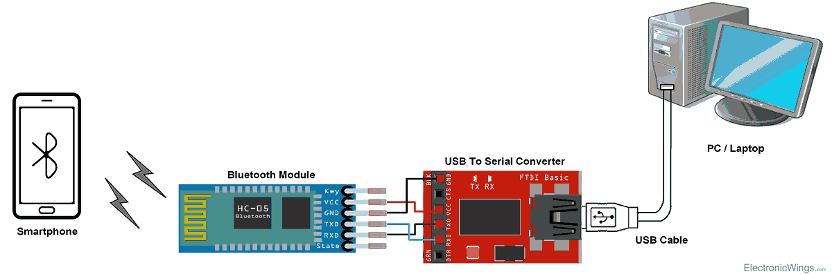

# **Command Mode**

* When we want to change settings of HC-05 Bluetooth module like change password for connection, baud rate, Bluetooth device’s name etc.
* To do this, HC-05 has AT commands.
* To use HC-05 Bluetooth module in AT command mode, connect “Key” pin to High (VCC).
* Default Baud rate of HC-05 in command mode is 38400bps.
* Following are some AT command generally used to change setting of Bluetooth module.
* To send these commands, we have to connect HC-05 Bluetooth module to the PC via serial to USB converter and transmit these command through serial terminal of PC.

|  |  |  |
| --- | --- | --- |
| **Command** | **Description** | **Response** |
| AT | Checking communication | OK |
| AT+PSWD=XXXX | Set Password  e.g. AT+PSWD=4567 | OK |
| AT+NAME=XXXX | Set Bluetooth Device Name  e.g. AT+NAME=MyHC-05 | OK |
| AT+UART=Baud rate, stop bit, parity bit | Change Baud rate  e.g. AT+UART=9600,1,0 | OK |
| AT+VERSION? | Respond version no. of Bluetooth module | +Version: XX OK  e.g. +Version: 2.0 20130107   OK |
| AT+ORGL | Send detail of setting done by manufacturer | Parameters: device type, module mode, serial parameter, passkey,etc. |

# **6.4 L298N Motor Driver Module**

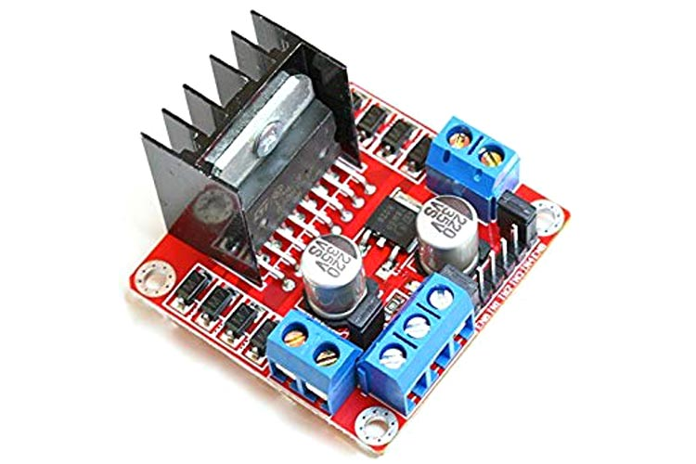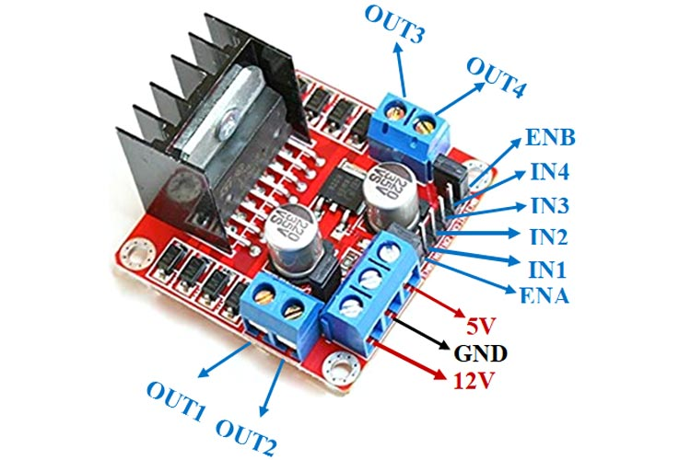

This **L298N Motor Driver Module** is a high power motor driver module for driving DC and Stepper Motors. This module consists of an L298 motor driver IC and a 78M05 5V regulator. **L298N Module** can control up to 4 DC motors, or 2 DC motors with directional and speed control.

### ****Features & Specifications****

* Driver Model: L298N 2A
* Driver Chip: Double H Bridge L298N
* Motor Supply Voltage (Maximum): 46V
* Motor Supply Current (Maximum): 2A
* Logic Voltage: 5V
* Driver Voltage: 5-35V
* Driver Current:2A
* Logical Current:0-36mA
* Maximum Power (W): 25W
* Current Sense for each motor
* Heatsink for better performance
* Power-On LED indicator

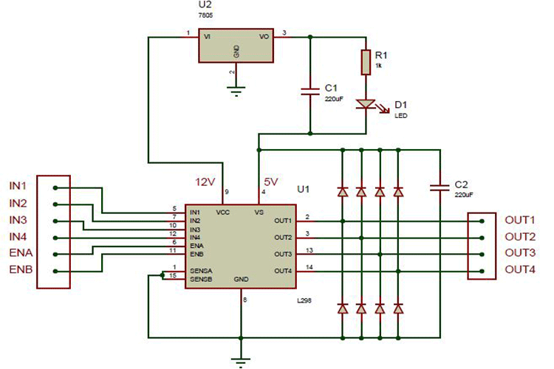

### ****Applications****

* Drive DC motors.
* Drive stepping motors
* In Robotics

**L298N Module Pinout Configuration**

|  |  |
| --- | --- |
| **Pin Name** | **Description** |
| IN1 & IN2 | Motor A input pins. Used to control the spinning direction of Motor A |
| IN3 & IN4 | Motor B input pins. Used to control the spinning direction of Motor B |
| ENA | Enables PWM signal for Motor A |
| ENB | Enables PWM signal for Motor B |
| OUT1 & OUT2 | Output pins of Motor A |
| OUT3 & OUT4 | Output pins of Motor B |
| 12V | 12V input from DC power Source |
| 5V | Supplies power for the switching logic circuitry inside L298N IC |
| GND | Ground pin |

# **6.5 150 RPM Single Shaft BO Motor - Straight**

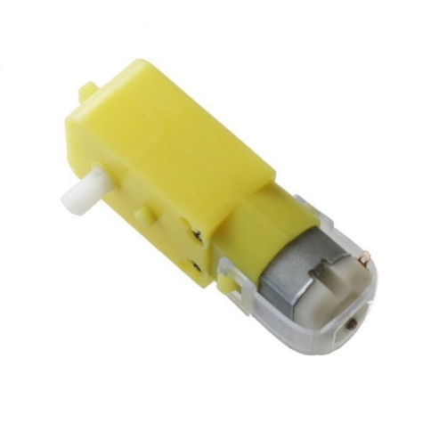

The 150 RPM Single Shaft BO Motor - Straight motor gives good torque and rpm at lower operating voltages, which is the biggest advantage of these motors.

Small shaft with matching wheels gives an optimized design for your application or robot. Mounting holes on the body & light weight makes it suitable for in-circuit placement. This motor can be used with 69mm Diameter Wheel for Plastic Gear Motors.

It is an alternative to our metal gear DC motors. It comes with an operating voltage of 3-12V and is perfect for building small and medium robots.

The motor is ideal for DIY enthusiasts. This motor set is inexpensive, small, easy to install, and ideally suited for use in a mobile robot car. They are commonly used in our 2WD platforms.

**Specifications of 150 RPM Single Shaft BO Motor - Straight:-**

* Shaft length: 7 mm
* Shaft Diameter: 5.5 mm
* Size: 55 x 48 x 23 mm.
* Operating Voltage: 3 to 12V.
* Current (without loading): 40-180mA.
* RPM: 150 rpm.
* Output Torque: 0.8 kg cm.

**Features of 150 RPM Single Shaft BO Motor - Straight:-**

* Cost-effectiveness of the injection-molding process.
* Elimination of machining operations.
* Low density: lightweight, low inertia.
* Uniformity of parts.
* Capability to absorb shock and vibration as a result of elastic compliance.
* Ability to operate with minimum or no lubrication, due to inherent lubricity.
* The relatively low coefficient of friction.
* Corrosion-resistance; elimination of plating, or protective coatings.
* The quietness of operation.
* Tolerances are often less critical than for metal gears, due in part to their greater resilience.
* Consistency with the trend to greater use of plastic housings and other components.